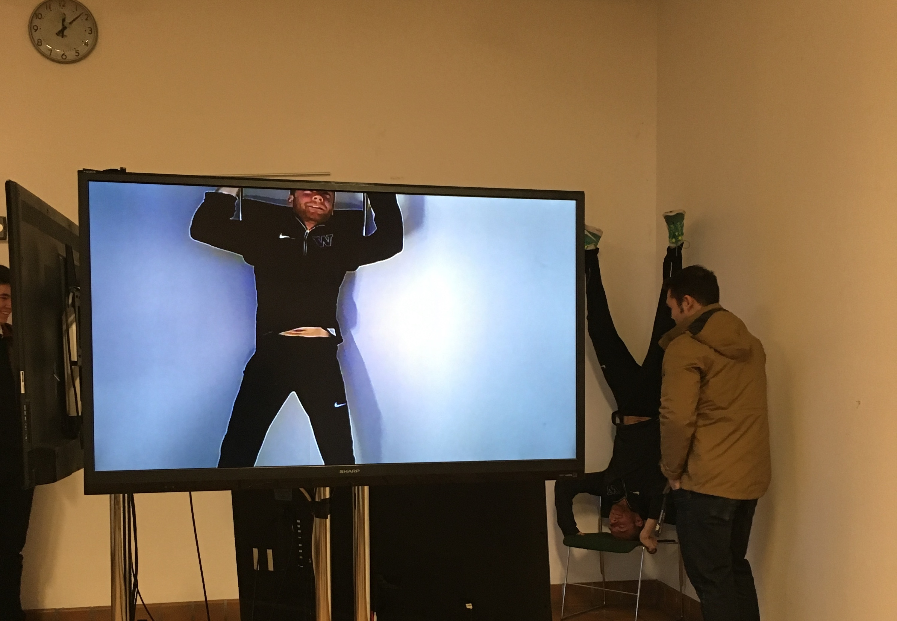

TV & Video

50” x 24”

Received: 3.7

Time Spent: 5 hours

Initial Reaction: 6/10

Cost of Materials: $0

This work was received okay in crit and received an overall grade of 3.7 upon evaluation. The total hours/money spent on labor and cost of materials was below average.

Add To Cart: **$75** [See Pricing Sheet](Pricing%20Sheet.docx)

Paper, Ink & Tape

11”x 5”

Received: 3.7

Time Spent: 15 hours

Initial Reaction: 7/10

Cost of Materials: $62

This work was received well in crit and received an overall grade of 3.7 upon evaluation. The total hours spent on labor was above average and cost of materials was average.

Add To Cart: **$287** [See Pricing Sheet](Pricing%20Sheet.docx)

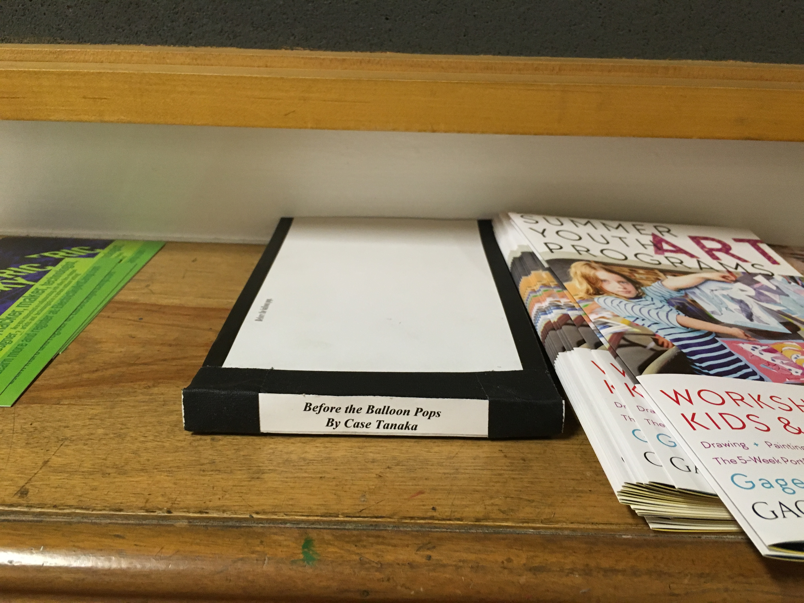



Paper & Ink

11.5” x 8”

Received: 3.7

Time Spent: 7 hours

Initial Reaction: 5/10

Cost of Materials: $34

This work was received not so well in crit and received an overall grade of 3.7 upon evaluation. The total hours/money spent on labor and cost of materials was below average.

Add To Cart: **$139** [See Pricing Sheet](Pricing%20Sheet.docx)

4x5 film & Hair

14” x 14”

Received: 3.7

Time Spent: 8 hours

Initial Reaction: 5/10

Cost of Materials: $46

This work was received not so well in crit and received an overall grade of 3.7 upon evaluation. The total hours/money spent on labor and cost of materials was below average.

Add To Cart: **$166** [See Pricing Sheet](Pricing%20Sheet.docx)

